Programming Assignment #3
(for Ch 4 and 5)

Problem Description

A mail-order house sells five different products whose retail prices are as follows: product 1, $2.98; product 2, $4.50; product 3, $9.98; product 4, $4.49; and product 5, $6.87. Write an application that reads a series of pairs of numbers as follows:
- Product number
- Quantity sold for one day
Your program should use a switch structure to help determine the retail price for each product. It should calculate and display the total retail value of each products sold last week. Use a sentinel-controlled loop to determine when the program should stop looping and display the final results.

Note: This problem is question 5.17 on page 194. Please see additional requirements at the end of this web page.

Sample Run
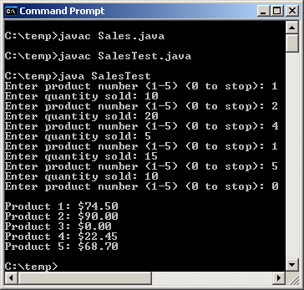

Problem Requirement
a) Your program must produce the prompt and the output the same as given.
b) Your program should run correctly with the same inputs and outputs as given in the sample run.
c) Your program must use a switch structure to check the product number.
d) The total retail value of each product should be displayed with currency.

Bonus Program
a) Make duplicate copy of Sales.java and SalesTest.java. Name the new copy as Sales2.java and SalesTest2.java.
b) Review Sales2.java and SalesTest2.java so that JOptionPane is being used. See pages 185 in ch 5 and 552-553 in ch 14.
c) Your program must produce the same inputs and outputs as shown below.

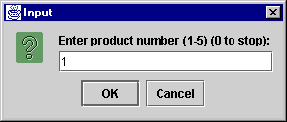 | 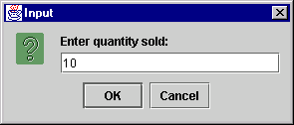
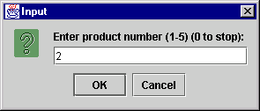 | 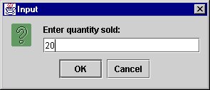
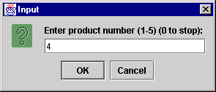 | 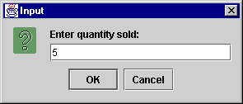
 | 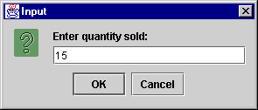
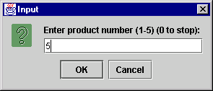 | 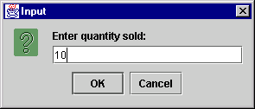
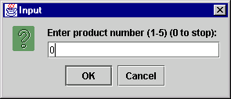 | 